PROVIDENT FUND DEPARTMENT
GUIDLINES TO E_NOMINATION – ONLINE PROCEDURE

PROCESS FLOW CHART FOR FILING ONLINE NOMINATION FORM IS AS UNDER:-

UAN Activation is Mandatory before filing E_Nomination.

Prior to E_Nomination the member has to creat aadhar VID (Virtual ID) which is valid for three months only. Step to creat VID (Virtual ID)

Visit to uidai.gov.in site - the following screen will appear.
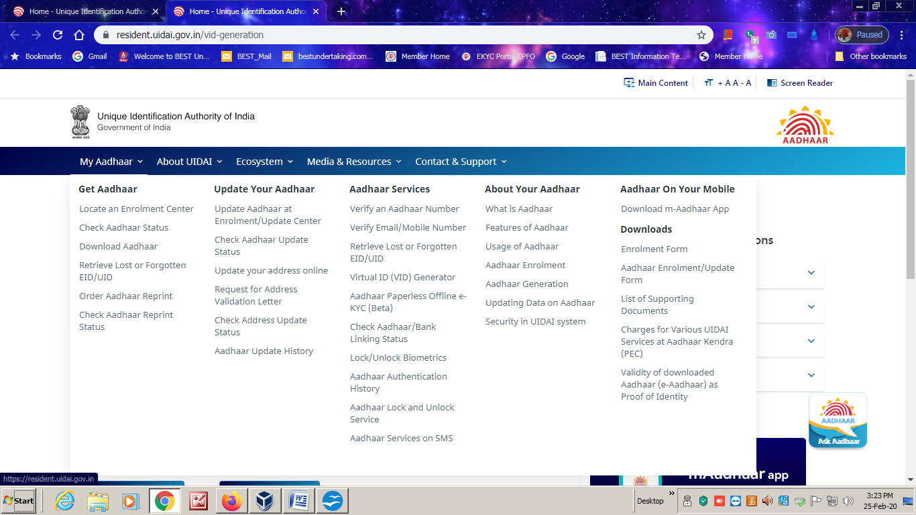
My aadhar
↓
Aadhar services
↓
Virtual ID (VID) Generator
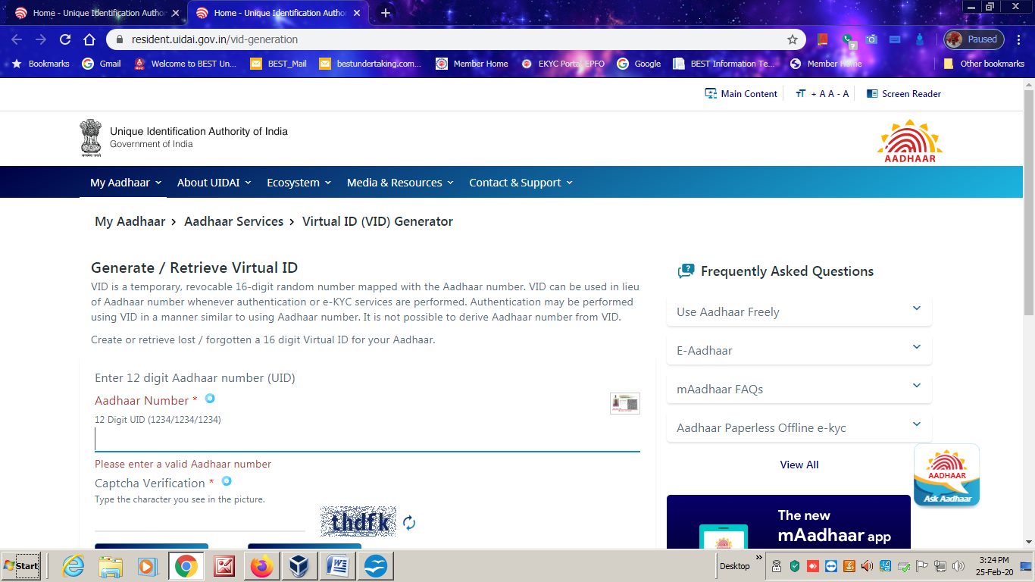
Enter Aadhr No >> Captcha>> send OTP >>Enter Aadhar OTP >> Generate VID >> member will get 16 digit VID Number through SMS on his/her registered mobile
PROCESS FLOW CHART FOR FILING ONLINE NOMINATION FORM IS AS UNDER:-
Open Google
Visit the EPFO UNIFIED PORTAL
The member has to log in on member home of epfo .Enter UAN>>password>> captcha. The following screen will appear.

The member has to complete his/her profile in view option. Click on view option profile following screen will appear.
Home -- view -- manage -- Account -- online services
↓
Profile
Upload Photograph of member and fill up permanent and current address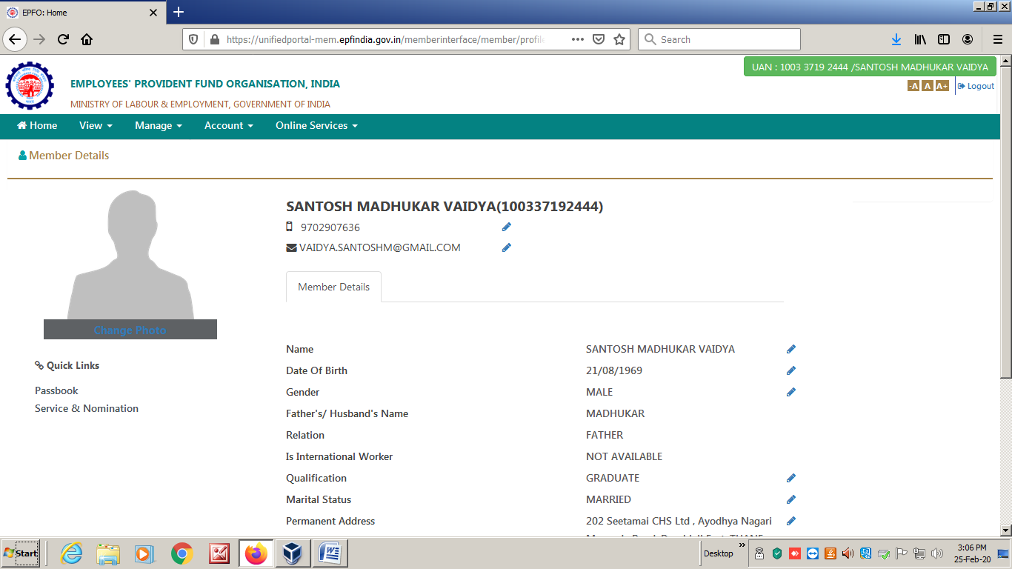
After uploading below 100 kb size photograph and updating permanent, current address, the following screen will appear.
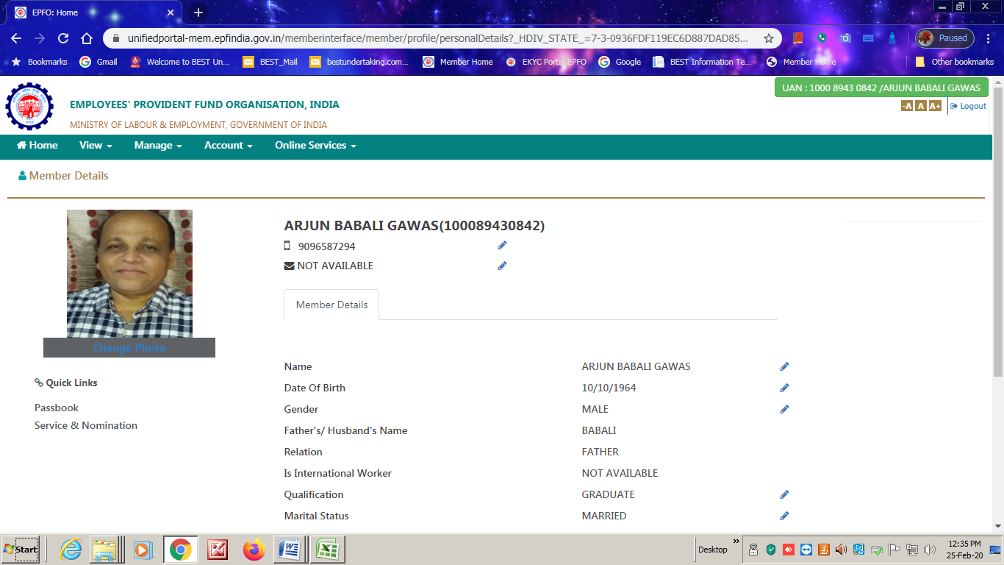
After completion of profile go to home click on manage >> E_ Nomination.
Home -- view -- manage -- Account -- online services
↓
E – nomination (Click)
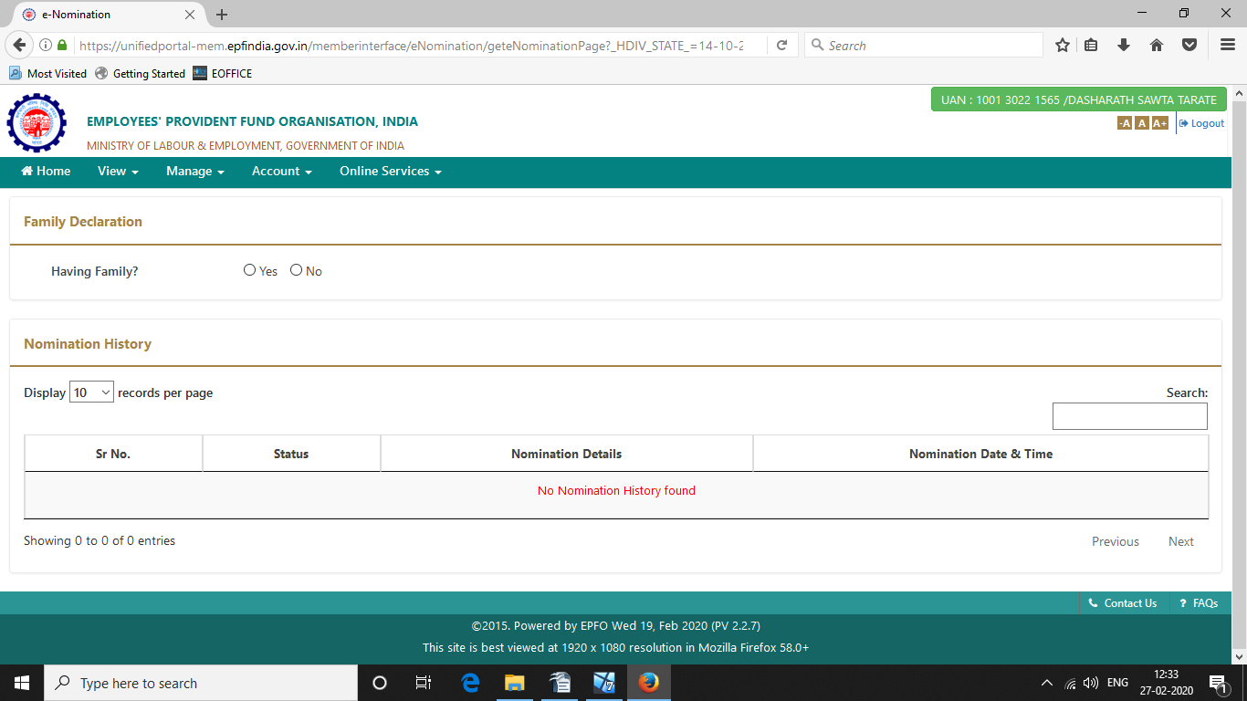
Click on E Nomination following screen will appear, then fill up the Family particulars and upload photograph of each family member.

After updating of Family particulars the following screen will appear.
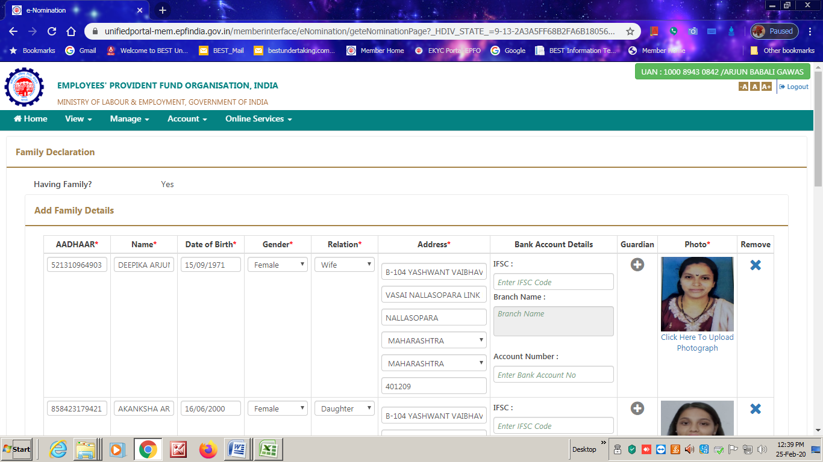
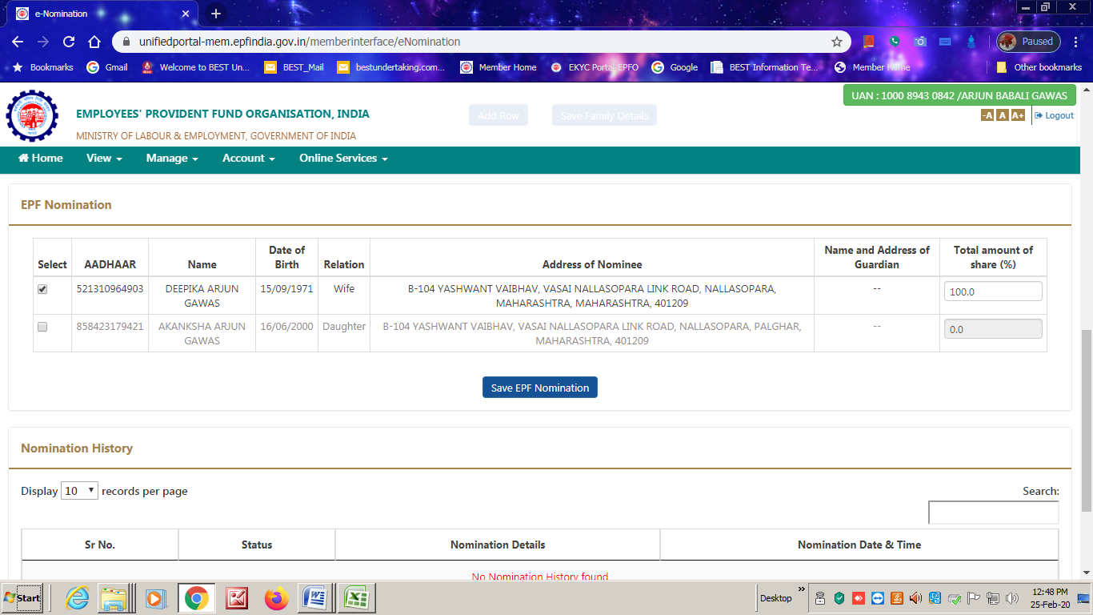
Click on Save for nomination. The Flowing screen will appear.
Click on esign >> enter VID Number which was created earlier >> Verify >> Click on E Hastakshar >> Enter VID or Aadhar number >> Get OTP >> Enter OTP >> Consent >> Submit
The following message will display on screen.
PDF signed Sucessfully.

Finally the following screen will displayed. Click on Nomination details the nomination form will be downloaded. 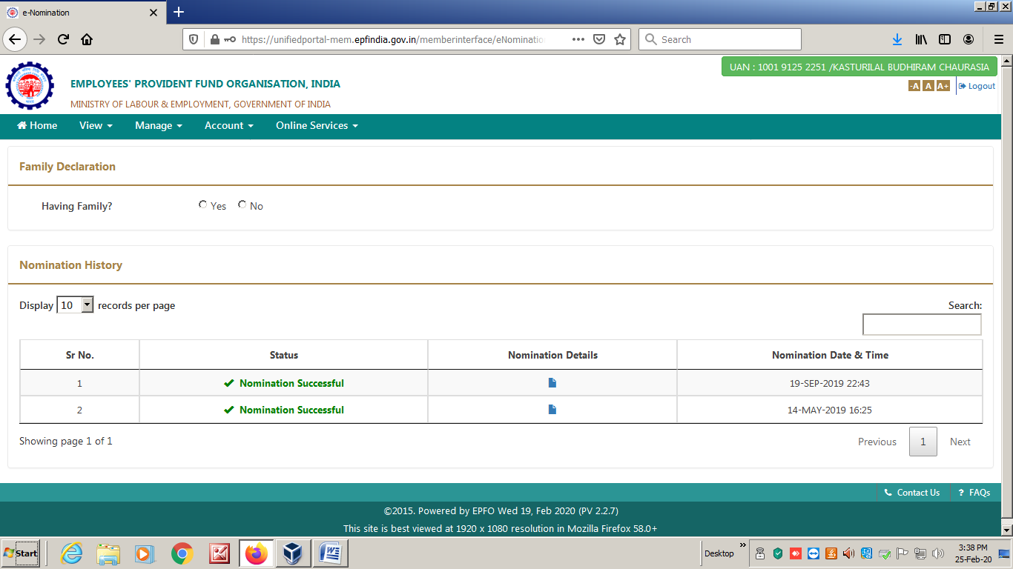
Final output of the e_nomination PDF File is attached separately. Take print of PDF File and preserve for further record.

