Help Document ACR (Annual Confidential Rpt)
- Open Chrome Browser

- Enter website address in address bar https://www.bestundertaking.co/ press Enter.
- After website Loading click on General Admin -> HRMS Menu
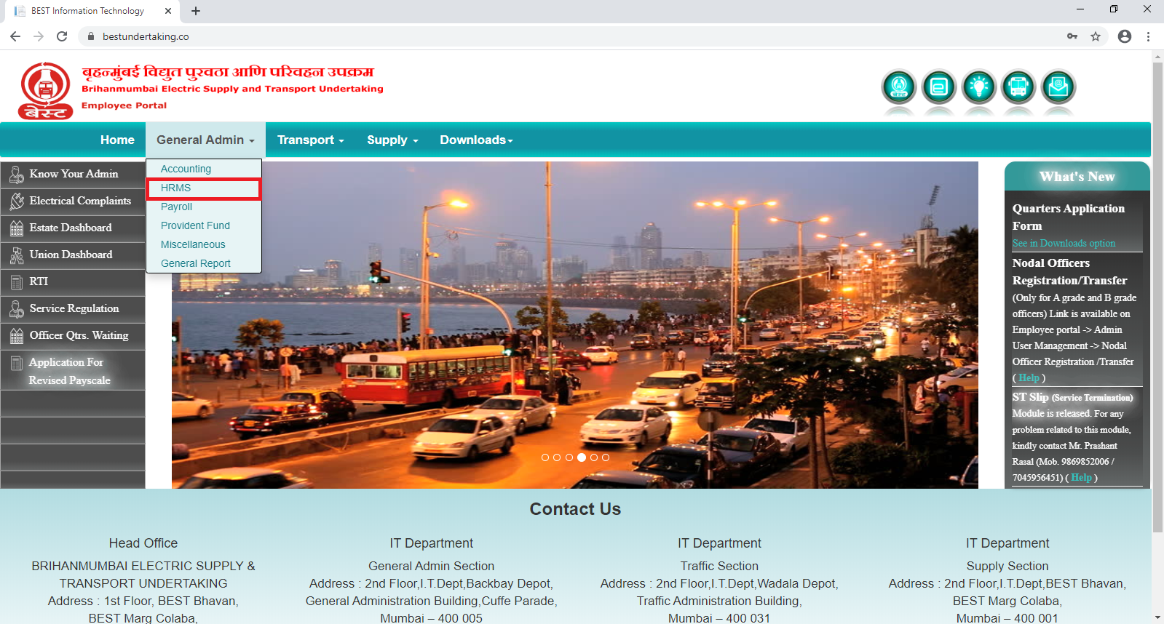
- Enter User Name , Password and Click on Sign In Button
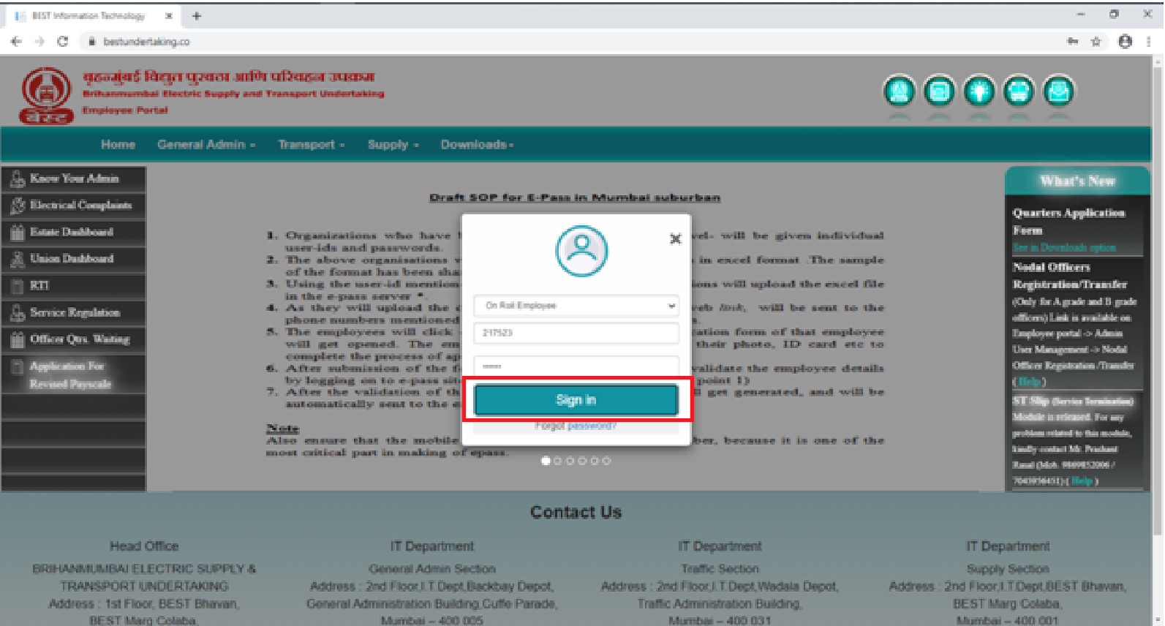

5) After loading dashboard Click on ACR Icon Or HRMS -> Annual Confidential Rpt Menu.
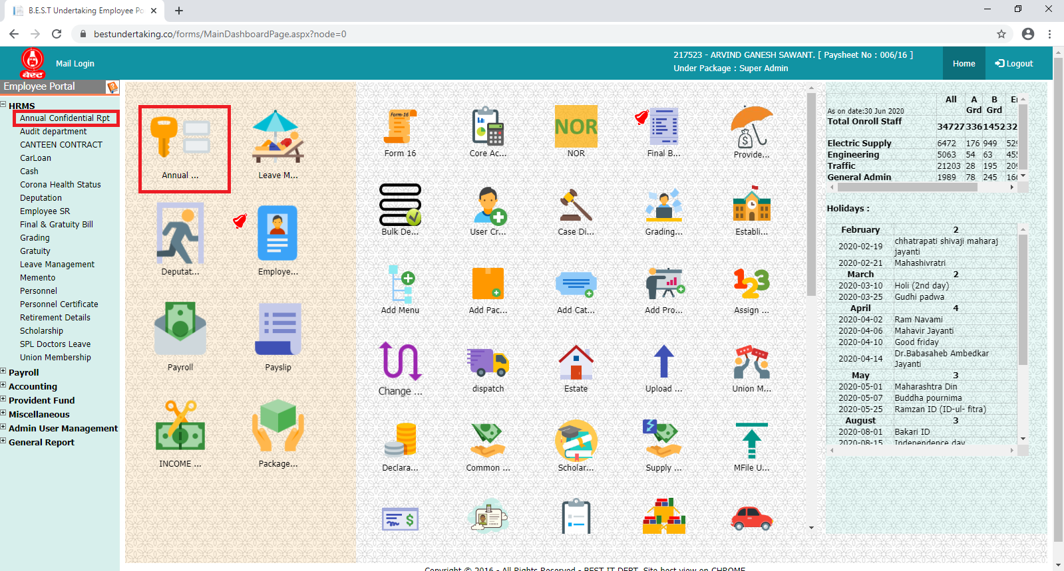

6)
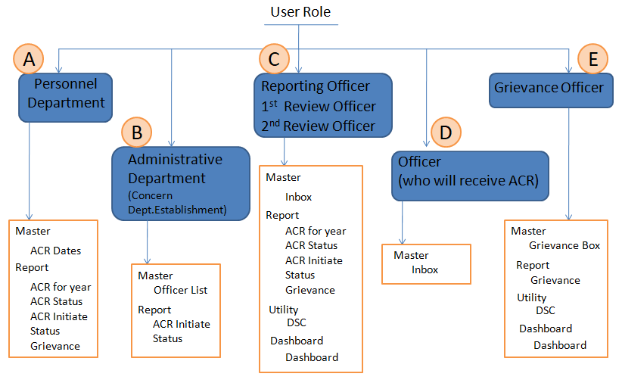
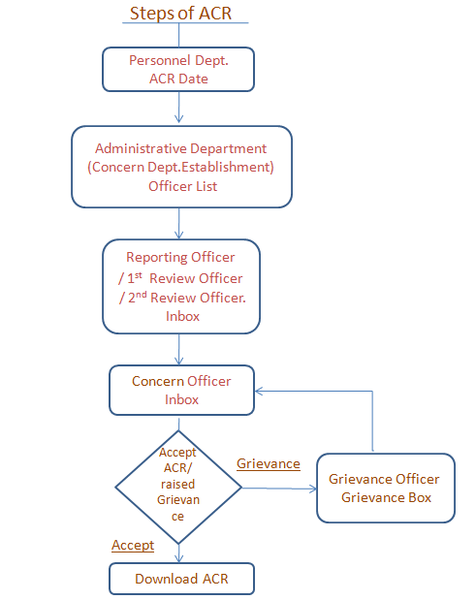
- Personnel Department
- Click on MASTER-> ACR Dates
- ACR Dates Screen will open
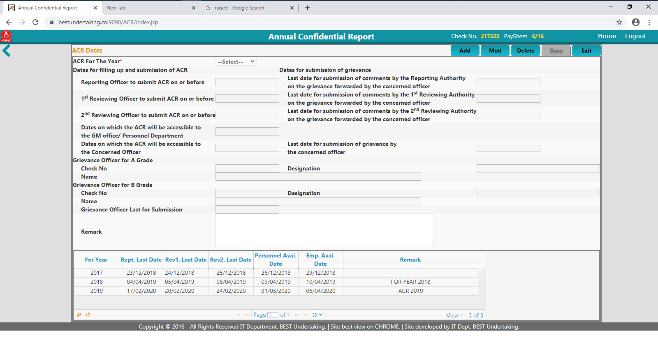

- Click on Add Button.
- After that fill up the all necessary information click on Save Button.

- Administrative Department (Concern Dept. Establishment)
- Click on MASTER-> Officer List
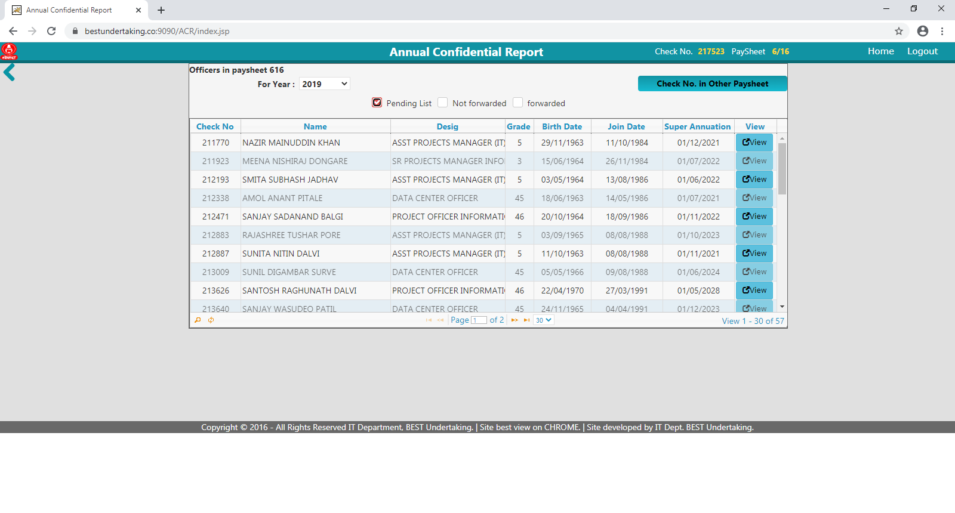
- In case of other Paysheet officer ACR Details to initiated and Forward click on button.
OR

- Then Select
- Pending List Checkbox for getting all Officer List of ACR initiate.
- Not Forwarded Checkbox for getting all Officer List of ACR details are initiated (fill up) but not Forwarded to concern Reporting Officers
- Forwarded Checkbox for getting all Officer List of ACR Forwarded to concern Reporting Officers

- After select on Pending List Checkbox then Click on View button.
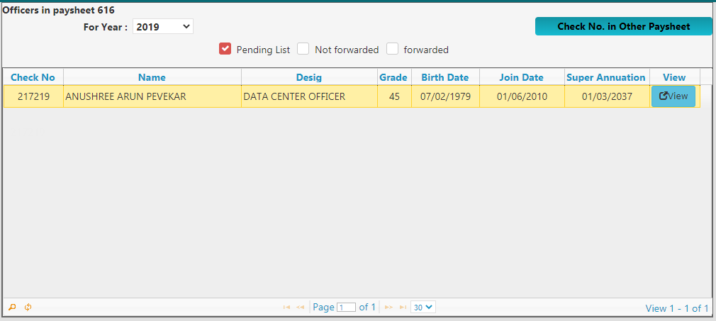
- After Click on View button following screen will be available then click on add button.

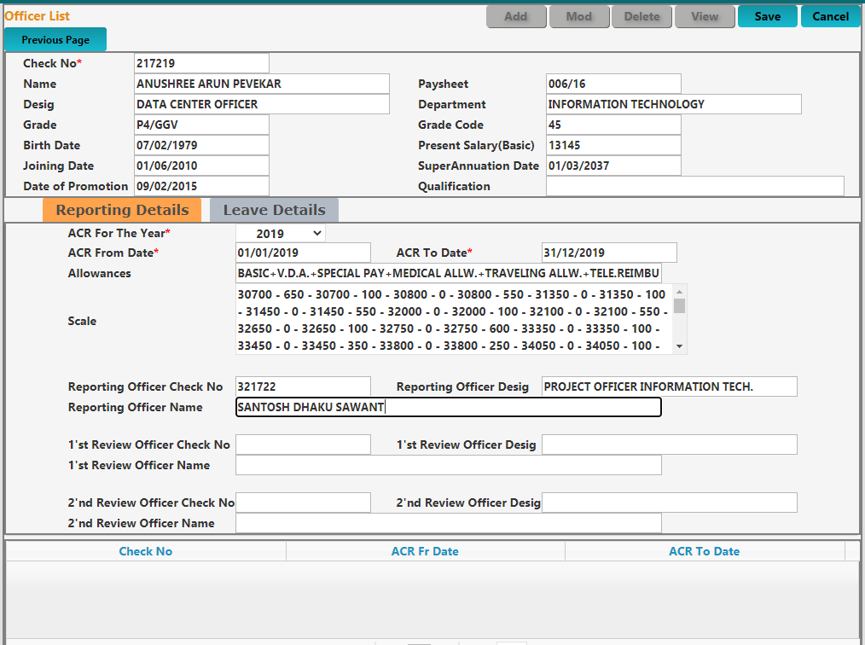

- Relevant Information should be added then click on Save button
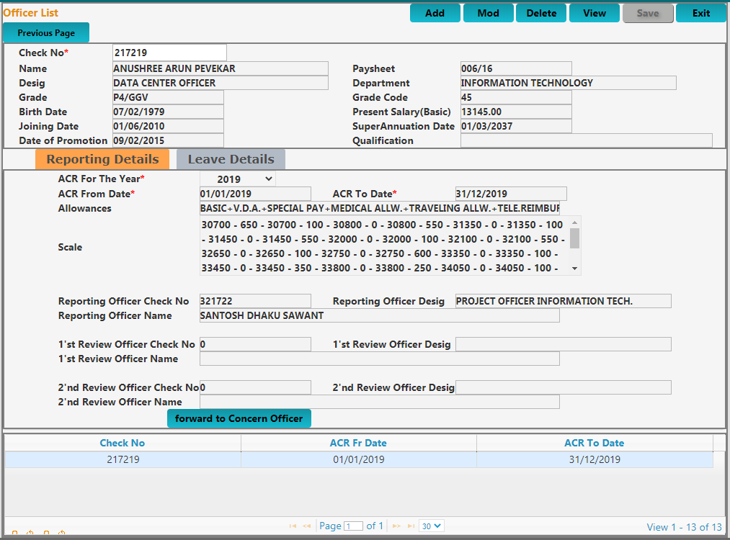
- Then click on button so that initiated ACR will receive to Respected Reporting Officer.

- Reporting Officer / 1st Review Officer / 2nd Review Officer.
- Click on UTILITY-> DSC
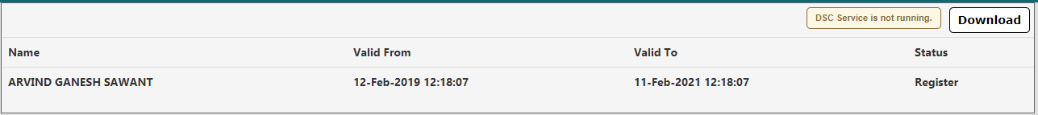
- If your name will not display then your DSC is not Register for ACR. Then click on button
DSC Setup will be download.

- Then double click on DSC setup -> enter password 123 in textbox click next button.
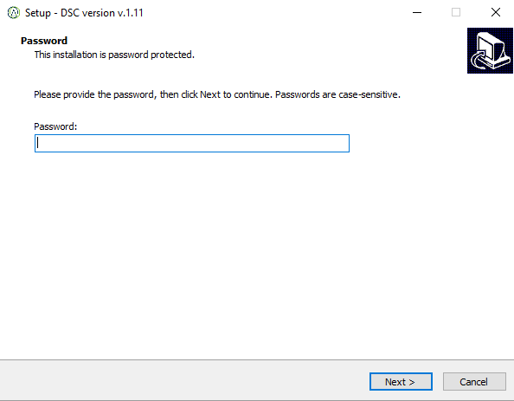
- Select checkbox create a desktop shortcut and then click Next Button
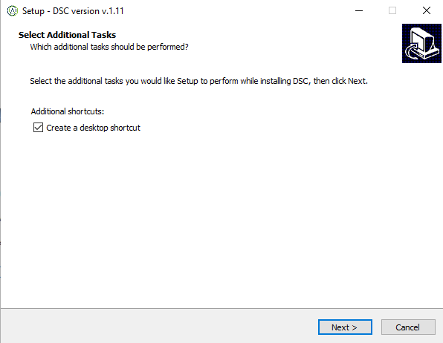
- Click on Install button
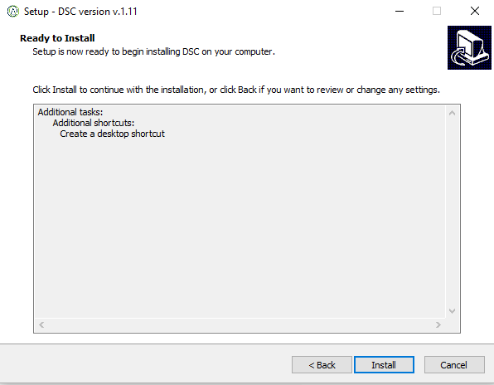

- Click on finish button
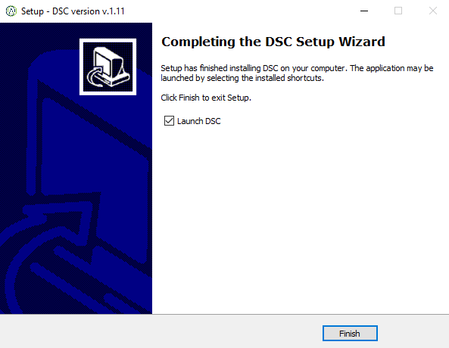
- After Sucessful installation following screen Message will be Popout click Ok.
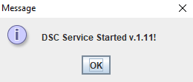
- This setup will execute only Once.
- Click on UTILITY-> DSC
- Enter DSC Password then click ok button.
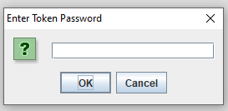
- Then Click Ok.
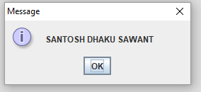
- After successful registration of DSC following details are display on screen.
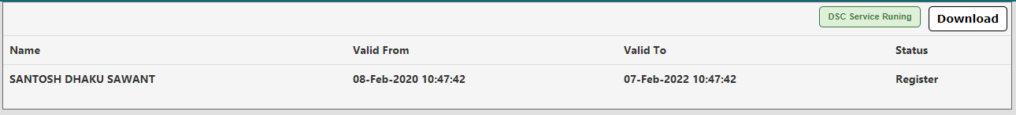

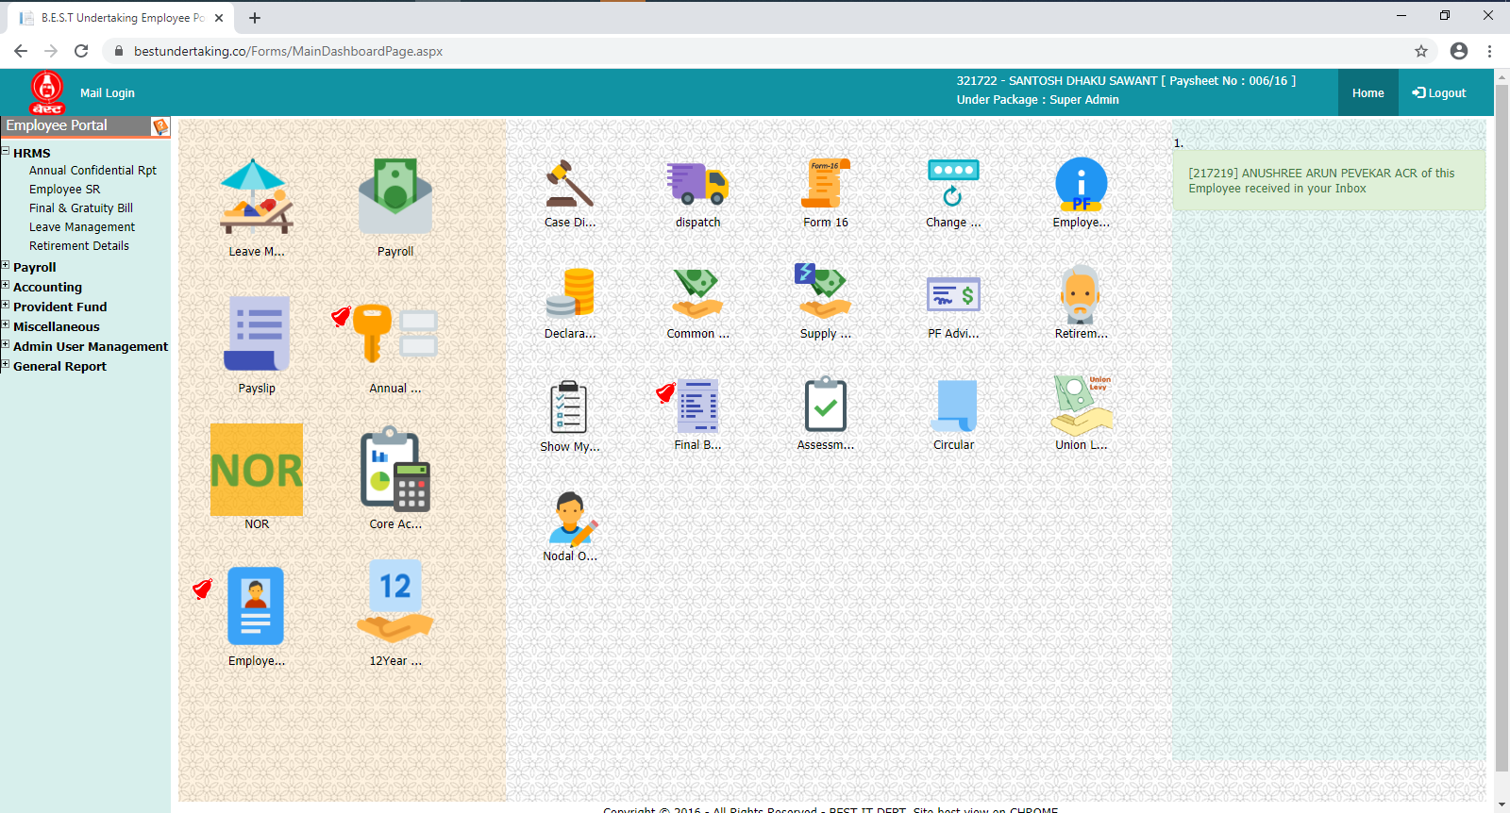

- Click on Master-> Inbox
- Select for Year then list of Pending Officer with View button will be available.
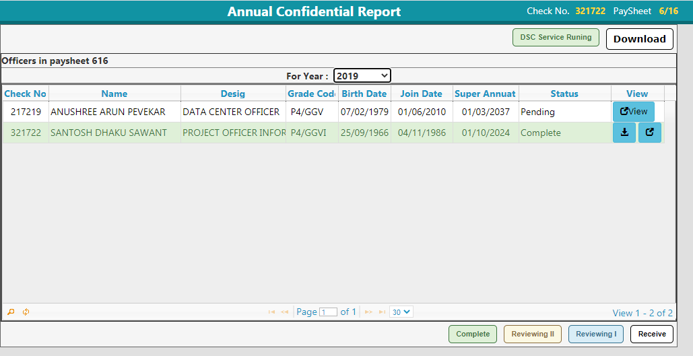
- Click on View Button.
- After click on View Button Following screen will be available.
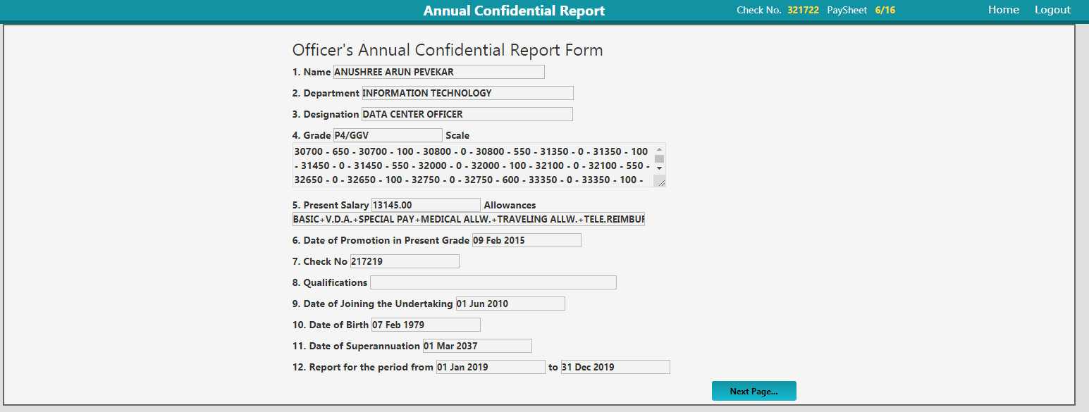

- Check concern officer Details which is fillup by respected establishment before click on Next Page button.
- Next Screen will be Leave Details if you want go to Previous Page then click on Previous Page else Click On Next.
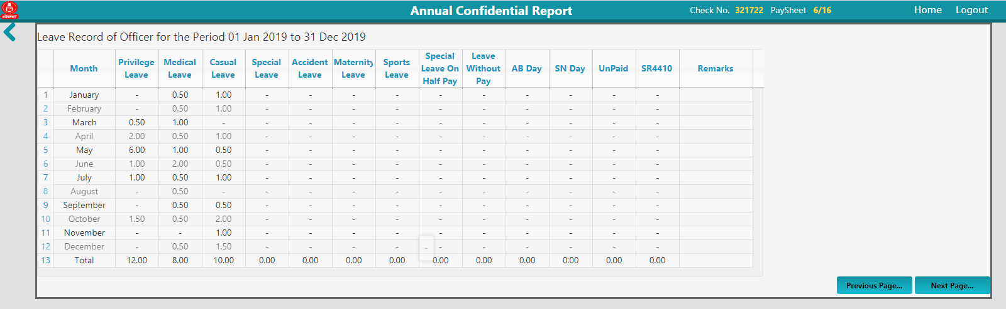
- Next Screen will be Marks Screen
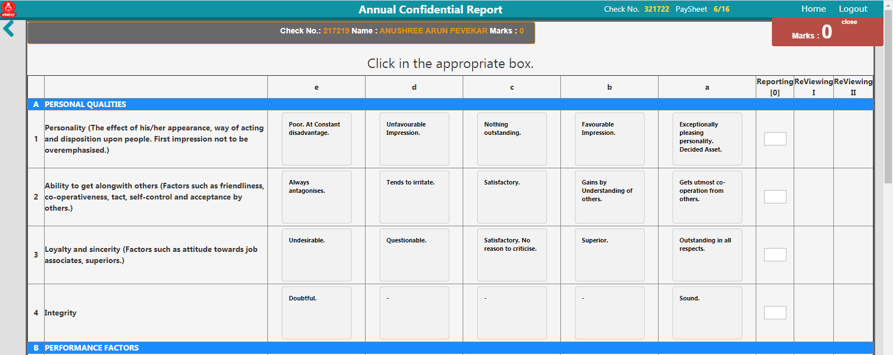

- After clicking appropriate box a, b, c, d, e . Tick marks will be appearing and also Mark will be calculating base on selection.
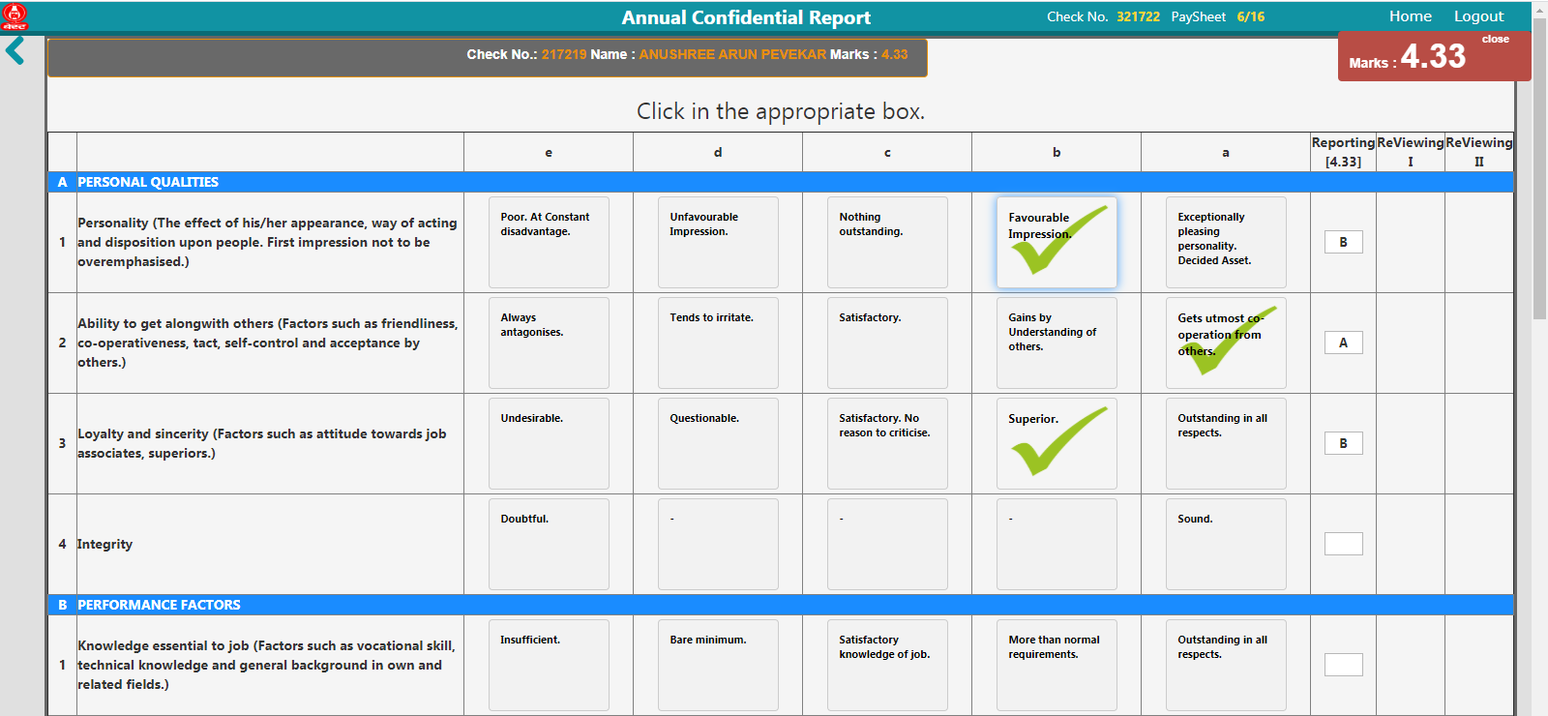
- After Selecting all box Click on Remark Section to fillup the remark.
- Before clicking Save & Forward button make sure that DSC is connected to Computer/ Laptop.
- DSC is not Connected then it will throw the message DSC is not connect and ACR marks Data will not be save
- Enter DSC PIN Click Ok and wait for next message click Ok ACR marks Data will be save & redirect to Inbox.
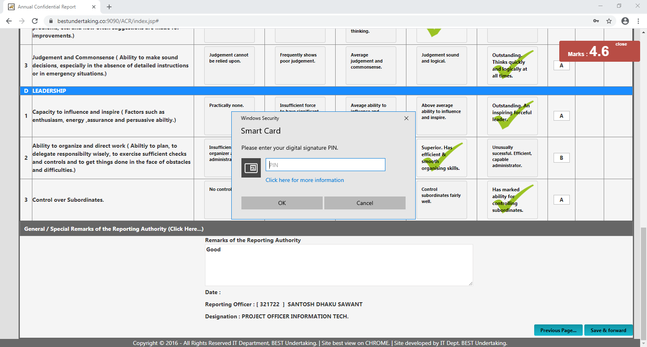
Or
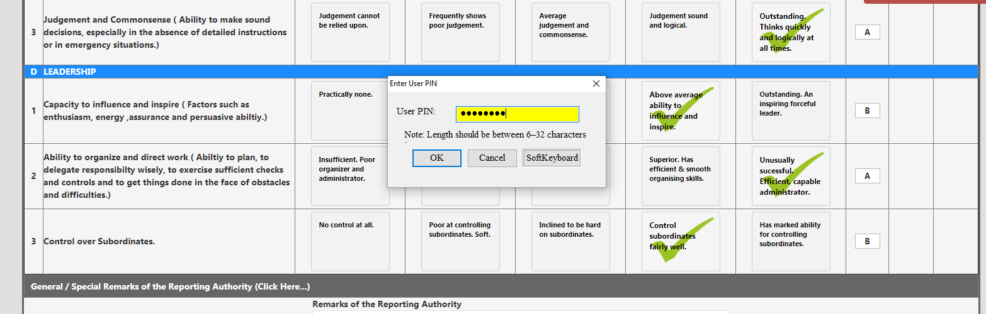

- After Successfully Marks Save Respected Officer ACR will be Generated / forwarded to next 1st Review Officer / 2nd Review Officer.
- All Respected Officer will receive ACR on relevant date which is specified by Personnel department.

- Officer.
1) After receiving ACR in MASTER->Inbox click on View button
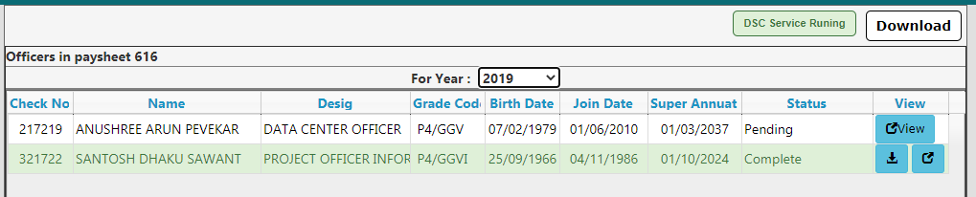
2) After click on View Button Following screen will be available.

3) Check Details which is fillup by respected establishment before click on Next Page button.

4) Next Screen will be Leave Details if you want go to Previous Page then click on Previous Page else Click On Next.
- Next Screen will be Marks Screen
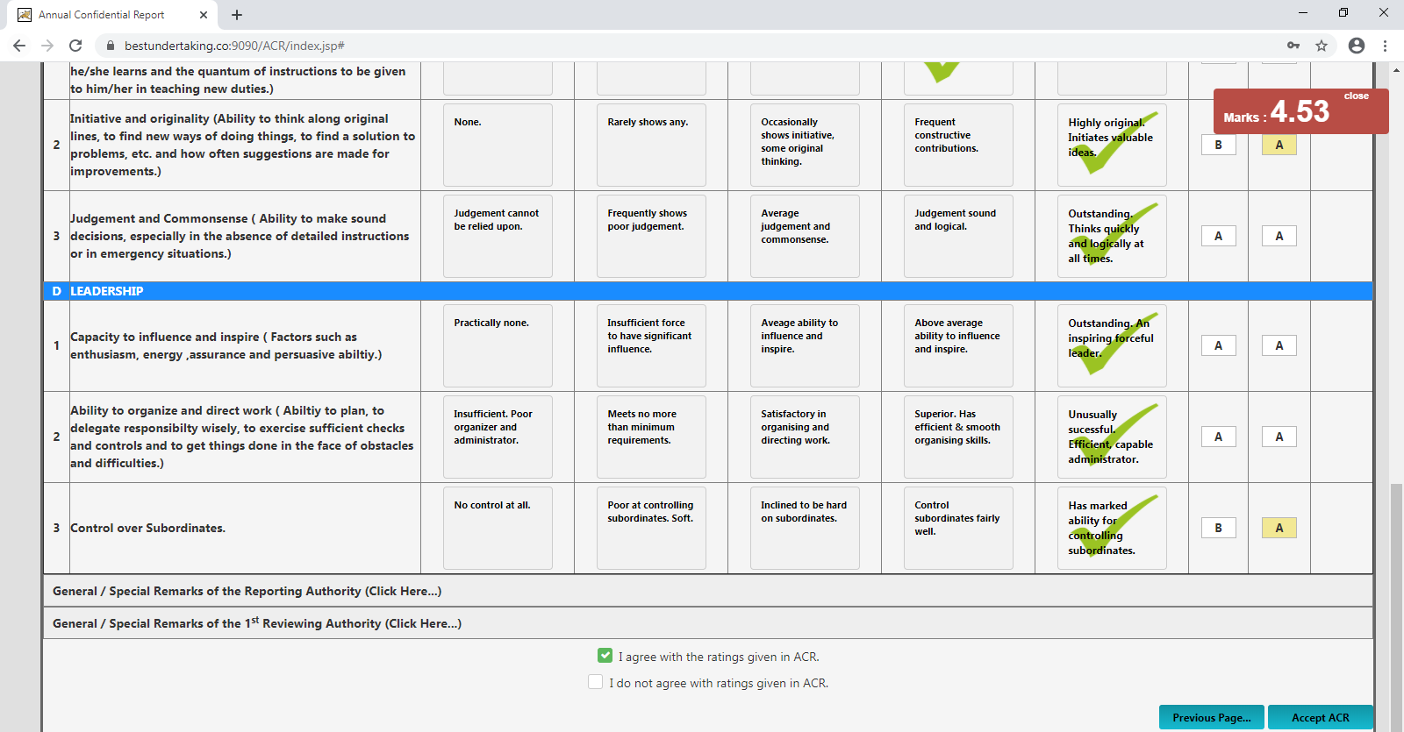
- Click on I agree with the rating given in ACR and then Click Accept ACR Button
Or
Click on I do not agree with the rating given in ACR and then Click Grievance Botton
- Then confirmation message will pop out click Ok Button


- Then Grievance Screen will appear.
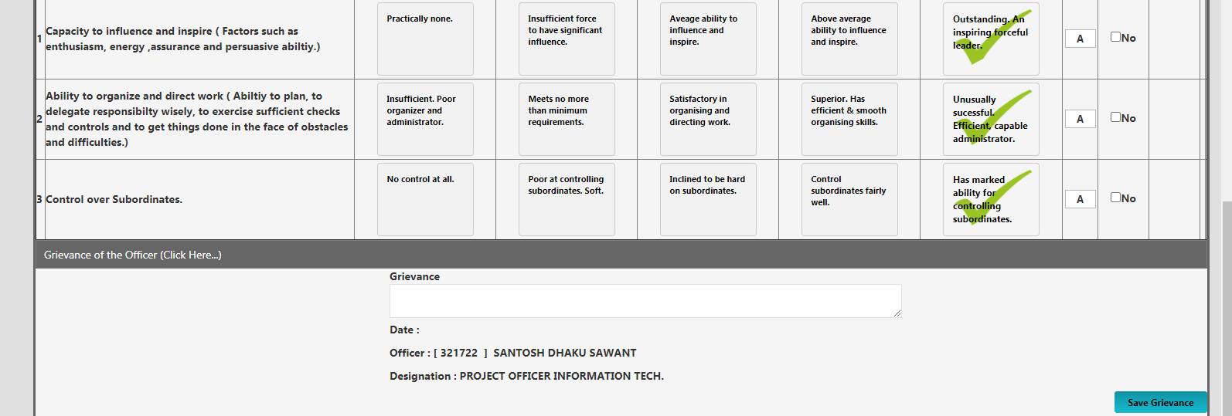
- Click on Grievance Section checkbox where you have grievance and Enter Grievance on given textbox, Click on Save Grievance button For Submitting Grievance.

- Grievance Officer.
- All grievance ACR will be receive in MASTER->Grievance Box
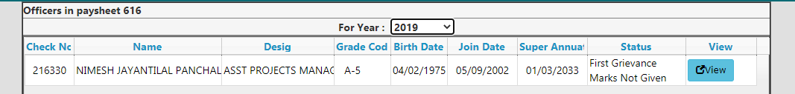
- Click on  Button
- Grievance details will appear.
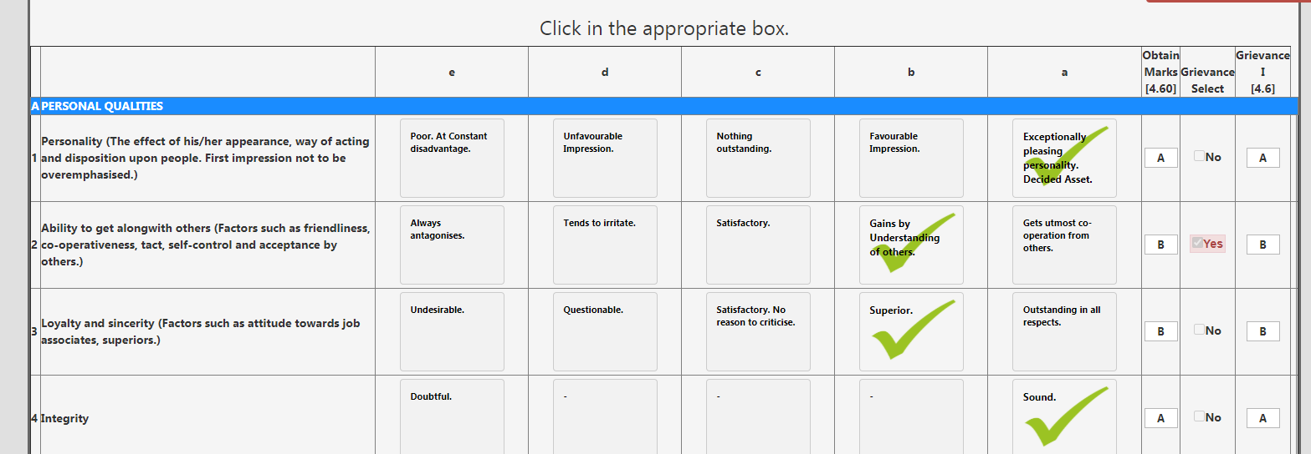
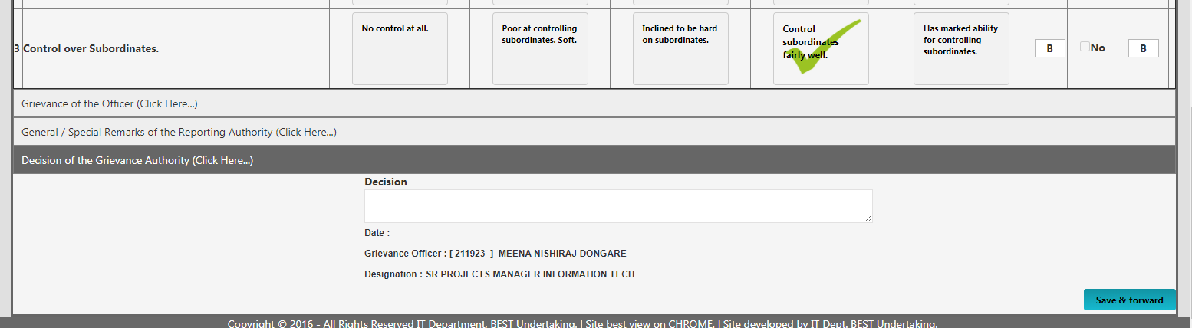
- In Grievance Select column Grievance section row will displayed Red Color Yes with Check mark.
Grievance officer will have rights of changing marks or not. After given all decision enter Decision in textbox and Click on Save & forward button to save the Decision.
After Successfully Decision saving screen will redirect to Grievance Box.

